Bumpers Requirements Analysis Document (RAD)

Version 2

Contents
1. Introduction 3
1.1. Purpose of the system 3
1.2. Objectives 3
2. Proposed System 3
2.1. Overview 3
2.2. Functional Requirements 3
2.2.1. Download and install the Bumpers game 4
2.2.2. Start the game 4
2.2.3. Stop the game 4
2.2.4. Drivability of Bumpers cars 4
2.2.5. Change the direction of the driven car 4
2.2.6. Change the speed of the driven car 4
2.2.7. Collide the user driven car with a computer-controlled car 4
2.2.8. Configure the cars 4
2.3. Nonfunctional Requirements 5
2.4. System models 5
2.4.1. Scenarios 5
2.4.2. Use case model 6
2.4.3. Object model 10
2.4.4. Dynamic model 15

Introduction

Purpose of the system
The purpose of Bumpers is to provide a simple, fast and cheap one-player interactive car collision game, with a high fun factor.

Objectives
The objectives of the Bumpers project are to:
- provide a simple, fast and interactive car game with a high fun factor.
- platform independence.
- easy administration. The player should be able to do all administrative work during installation.

Proposed System

Overview
The game Bumpers is a one-player car game application The Bumpers user interface displays a game board, which consists of an arbitrary number of cars, a tool bar with game control buttons and an instrument panel. One car, which is placed in the upper left corner of the game board, has a different body than all other cars and is visible in the instrument panel with the label “your car”. This is called the player’s car. All other cars are randomly distributed over the board. Two types of cars with different bodies are visible. These cars are slow and fast and controlled by the computer.
During a game, all cars drive with individual speeds over the game board. The speeds of the computer-controlled cars change at any time. The game board boundaries limit a car position. A car changes its driving direction, when it reaches a boundary. The player can change the speed and the direction of his car with the mouse. The player wins the game, if his car wins all collisions against all computer-controlled cars. He looses, if a computer-controlled car wins the collision.

Functional Requirements
The Bumpers player should be able to:
- download and install the Bumpers game
- start the game
- stop the game
- change the direction of the driven car
- change the speed of the driven car
- collide the user driven car with a computer-controlled car
- configure the cars

Download and install the Bumpers game
The player can choose and download a Bumpers compressed executable file from the Bumpers download web page. The Bumpers download page offers executables for at least Windows and Mac OS X. Bumpers is installed after decompressing the downloaded file.

Start the game
The player starts a game, by starting the application and pressing the start button of the tool bar. The button is disabled after the game is started.

Stop the game
The player stops a game, by pressing the stop button of the tool bar. The button is disabled when the game is stopped.

Drivability of Bumpers cars
The game board is a rectangle with a boundary on each side. Each car is moving with its speed into its direction. If a car reaches a boundary, the angle of the direction is 90˚ plus the angle of incidence.

Change the direction of the driven car
The player can change the driving direction of the controllable car, by clicking with the mouse into the game board. The driven car changes its direction and starts moving to the clicked position.

Change the speed of the driven car
The player can change the speed of the car by using speed control buttons located in the instrument panel.

Collide the user driven car with a computer-controlled car
The player can collide the controllable car with a computer-controlled car. If the player’s car is on a higher game board position, the computer-controlled car crashes and does not drive any more. The player wins the game, if all computer-controlled cars are crashed. The player looses the game, if his car is crashed by a collided computer-controlled car.

Configure the cars
The player can set the number of fast and slow computer-controlled cars and the number of frames per second, which defines the time interval of moving and repainting the cars on the game board. Furthermore, he can select images from a library that are used as car body. The selection is done within a preferences dialog window.

Nonfunctional Requirements
Simple to play. The user interface and the rules of playing Bumpers must be intuitive. A player should learn how to play, by playing a couple of trial games.
Interactive. Bumpers should support smooth car movements.
User interface. All relevant information of the driven car must be visible to the player. This includes the speed and the position of the car.
Crash safe. The Bumpers application should be crash safe.
Short response time. The startup time of the game must be low. The response time to a mouse click allows real time interaction.
Different car types. The Game must support fast and slow computer-controlled cars. The fast car that does not change its direction until it reaches the boundary of the game board. The slow car may change its direction any time. Both kinds of cars should be able to change their speed. They have a different minimum and maximum speed.
Customizability. Bumpers must be adaptable for the differences of two markets in North America and Europe, that is, it must support the metric and imperial measurement systems.
Multiple platforms. The game must run on different platforms.
Programming language. Bumpers must be implemented in Java.
The executable Bumpers game must be available over the web. All needed files must be compressed in standard compressing file type.

System models

Scenarios

Starting Bumpers
The Bumpers user interface displays a game board, which consists of an arbitrary number of cars, a tool bar with game control buttons and an instrument panel. One car, which is placed in the upper left corner of the board, has a different body and color than all the other cars. The same body is visible in the instrument panel with the label “your car”. All other cars are randomly placed over the board. Two types of cars with different body are visible. These are slow and fast computer-controlled cars. The game is ready to play.

Playing a Bumpers game
Alice presses the “start” button on the tool bar. The car, driven by Alice, is located at the upper left corner and waits for instructions from Alice. All the other cars start to drive in different directions with different speeds. An instrument panel displays the current speed and position of Alice’s car. Alice can control the car speed, by clicking on the speed control button. She can change the driving direction by clicking with the mouse at a specific position on the board. Her car changes its direction to the clicked position. A car changes its direction also, if it reaches any boundary of the game board. The angle of incidence is the angle of reflection.

Winning a Bumpers game
If Alice drives her car into a computer-controlled car from the higher game board position, the computer-controlled car gets crunched. It does not drive any more. If she can repeat this with all other computer-controlled cars, she wins and a dialog window with the text “Congratulation, you win!” appears. The window can be closed by pressing the “OK” button.

Loosing a Bumpers game
If any computer-controlled car drives into Alice’s car from a higher game board position, Alice looses and a “You lost!” dialog window appears. The window can be closed by pressing the “OK” button.

Configuring Bumpers
Alice presses the menu item “Preferences” from the Bumpers menu. A window with the bumpers settings appears. It contains a number of fast and slow cars, a number 'frame per second' and three images with the labels “slow car”, “fast car” and “driven car”. A “select” button is located next to each image. Alice can change the number of slow and fast cars and the number of the frames per second. By pressing a “select” buttons, Alice can select images from a library that are used as car body. After changing the settings, she presses the “OK” button and the preferences window disappears. The changes are reflected immediately on the game board

Use case model
The following diagram gives an overview of the identified use cases.

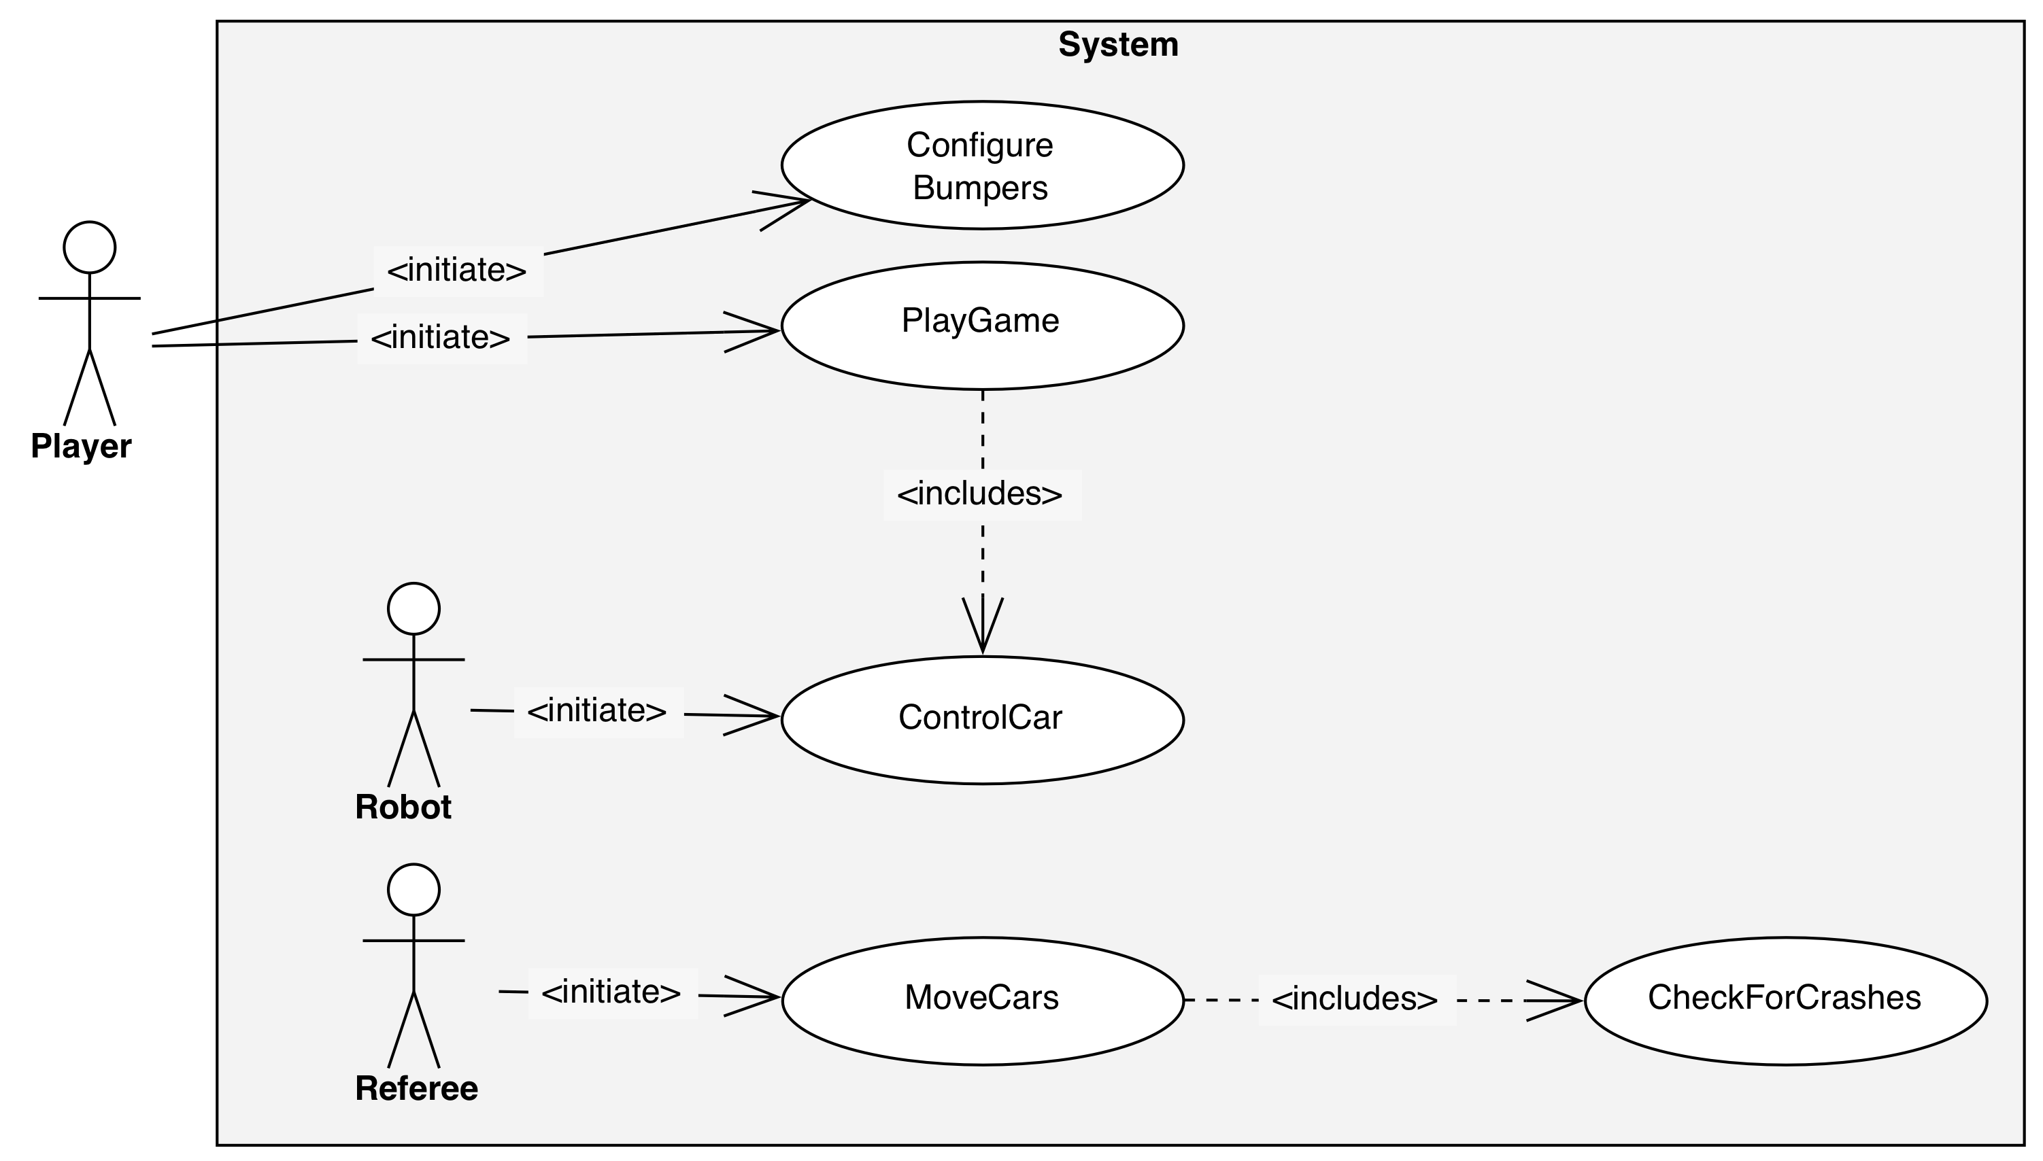
Figure 1: Overview of identified use cases (UML use case diagram).

The following actors are identified:
Player
The player is able to play games and to control his car. He can win or loose a game.
Robot
The robot is the enemy of the player. He controls all cars except the car of the player.

Referee
The referee controls the games. He moves the cars over the game board, detects collisions and declares the winner.

PlayGame
Use case Name | PlayGame
Initiating actor | Player
Preconditions | No game is running.
Flow of events | Actor Steps | System Steps
 | 1. The Player presses the start button of the tool bar.
 |  | 2. The system starts a new game by starting the robot and the referee to move and control the cars.
 | 4. By using the use case ControlCar, the Player can change the direction and speed of its driven car.
 | 5.1 If the Player presses the stop button from the tool bar,
 |  | 5.1.1 the system pauses the game and requests a stop confirmation.
 | 5.1.1.1 If the Player confirms,
 |  | 5.1.1.1.1 the system stops the game.
 | 5.1.1.2 If the Player rejects,
 |  | 5.1.1.2.1 the system continues the game.

ControlCar
Use case Name | ControlCar
Initiating actor | Player, Robot
Preconditions | A game is played.
Flow of events | Actor Steps | System Steps
 | 1.1 If the Player presses the speed control buttons located in the instrument panel,
 |  | 1.1.1 the new speed is set to the Player’s car, if it is in the range of the minimum and maximum car speed.
 | 1.2 If the Robot increments or decrements the speed of a car,
 |  | 1.2.1 the new speed is set to the car, if it is in the range of the minimum and maximum car speed.
 | 1.3 If the Player clicks with the mouse into the game board,
 |  | 1.3.1 the direction of the Player’s car is set to the clicked position.
 | 1.4 If the Robot changes the direction of a slow car,
 |  | 1.4.1 the direction is set to the car.

MoveCars
Use case Name | MoveCars
Preconditions | A game is running.
Initiating Actor | Referee
Flow of events | Actor Steps | System Steps
 | 1. Based on the direction and speed, the Referee computes a new position for all non-crunched cars within the game board boundaries.
 |  | 2. If a car reaches a boundary, a new direction with the rule: the angle of incidence is the angle of reflection is set to the car.
 | 3. By using the use case CheckForCollisions, the Referee tests if a car is crunched.
 | 4.1 If the Player’s car is crunched, the Referee declares the Player as looser and stops the game.
 | 4.2 If the Player’s car is not crunched and all others are, the Referee declares the Player as winner and stops the game.
 |  | 5 The system informs the Player that he won or lost.
Quality requirements | The Referee moves the cars during a whole game in a frequently time period that is defined by the frames per second property

CheckForCollisions
Use case Name | CheckForCollisions
Preconditions | A game is running.
Initiating Actor | Referee
Flow of events | Actor Steps | System Steps
 | 1. The Referee requests all car positions and sizes.
 |  | 2. The system returns all car positions and sizes.
3. The Referee computes the bounding boxes of the cars.
4. The Referee declares a collision if the bounding box of the player’s car and another car intersects.

CheckForCrash
Use case Name | CheckForCrash
Preconditions | This use case extends the CheckForCollisions. It is initiated when a collision between the player’s car and another car occurs.
Initiating Actor | Referee
Flow of events | Actor Steps | System Steps
 | 1. The Referee resizes the bounding boxes of the cars to 3/4 of its real size.
 | 2. The Referee declares a crash, if the resized bounding boxes intersect.
 | 3.1. If the player’s car resized bounding box is on a higher position,
 |  | 3.1.1 the player’s car gets crashed
 | 3.2. If the player’s car resized bounding box is on a lower position,
 |  | 3.2.1 the computer-controlled car gets crashed.

ConfigureBumpers
Use case Name | ConfigureBumpers
Initiating actor | Player
Preconditions | No game is played.
Flow of events | Actor Steps | System Steps
 | 1. The Player presses the preferences menu item.
 |  | 2. Bumpers displays the preferences dialog window. It consists of a number of fast and slow cars, a number frame per second and three images with the labels “slow car”, “fast car” and “driven car”. A “select” button is located next to each image.
 | 3. If the Player enters a new value for the number of fast cars, slow cars, or frames per second,
 |  | 3.1. the system validates if it is a number greater than zero. If the new value is valid, it is displayed. Otherwise it is reset to the old value.
 | 4. If the Player presses a “select” button next to one of the car body images,
 |  | 4.1. the system displays an open dialog.
 | 4.2. If the Player selects an image from the file system,
 |  | 4.3. the system closes the dialog and the selected image is displayed for the selected car.
 | 5. If the Player confirms his changes, in the preferences dialog,
 |  | 6. the system closes the dialog and all changes are set to the system.
Exit conditions | The game board reflects the changed settings of the player.

Object model
In this section we describe the Bumpers object model. First we describe related classes and give UML class diagrams to illustrate their relations. At the end we provide an UML class diagram containing all introduced classes.

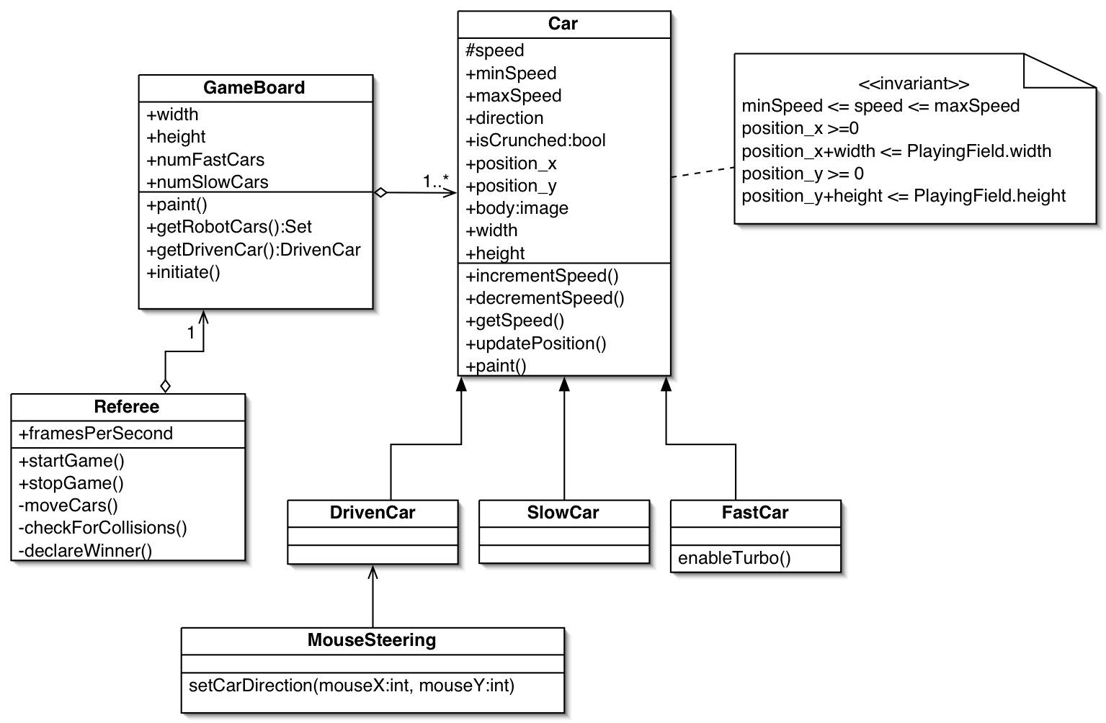
Figure 2: UML class diagram to illustrate the cars and the game board of Bumpers.
GameBoard:
The game board is a two dimensional rectangle. Its size is defined by the two attributes width and height. The lowest left point of the field has the coordinate 0,0. The highest right point of the field has the coordinate width, height. The size defines the boundaries of the game board. The game board consists of one to many cars. One car is the player driven car, the others are either slow or fast cars. The number of fast and slow cars is defined through the attributes numFastCars and numSlowCars. The player’s car can be accessed with the getDrivenCar method, the others over the getRobotCars. The paint method draws the game board and all cars at their current positions. The initiate method sets the driven car to the upper left corner of the game board and spread all other cars over the board.

Car:
The car class is the super class for all cars participating in Bumpers. A car drives on the game board with its speed into its direction. The speed must be in the range of the minSpeed and maxSpeed attributes. It can be incremented or decremented by the methods incrementSpeed and decrementSpeed. The direction is a degree between 0 and 360. The attribute isCrunched indicates if the car is crunched or not. If it is crunched, it cannot drive any more. The body attribute defines the image that is used for painting the car. The size of a car is defined by the width and height attributes. The position_x and position_y attributes define the actual position on the playing flied. They define the lowest left point of the car. The paint method paints the car with its body. Based on the direction and speed, the updatePosition method computes a new position.

FastCar:
The fast car class extends the car and inherits the car behavior. The enableTurbo method enables the fast speed of the car.

SlowCar:
The slow car class extends the car and inherits the car behavior. It has a different a lower minimum-maximum speed range than the fast car.

DrivenCar:
The DrivenCar class is the car controlled by the player. It extends the class car

MouseSteering:
The MouseSteering class enables the player to change the direction of the driven car. It listens to the mouse and reacts if the mouse is pressed within the game board. It computes the new direction of the driven car, based on the actual position of the car and the position of the mouse click.

Referee:
The class Referee controls the game. It is responsible for starting and stopping the game with the method startGame, stopGame. It moves the cars of the game board by the moveCars method in a periodic time interval, defined with the attribute framesPerSecond. The moving computes and sets the new positions of all cars. The game board and the cars are repainted afterwards. The referee uses the CheckForCollisions method to detect collisions between the driven car and any computer-controlled car. He declares the player as winner or looser of a game.

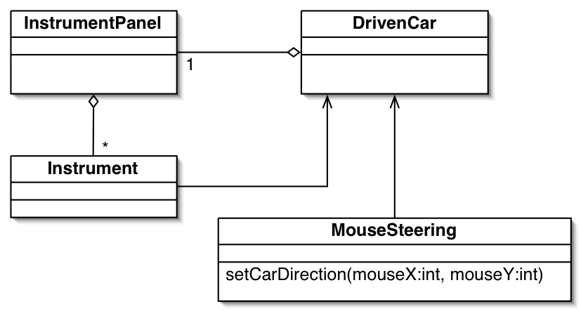
Figure 3: Introduction of the observer pattern to update the driven car instruments (UML class diagram).

InstrumentPanel:
The player’s car has an instrument panel that offers all instruments of the car to the player. It consists of an arbitrary number of instruments.

Instrument:
An instrument is a single unit of the player’s car that displays a state or interacts with the player’s car.

To inform the instruments of state changes of the player’s driven car, we use the observer pattern that introduces a Publisher and a Subscriber class.

Next, we have a view of the identified instruments that are responsible for visualizing the state of the player’s car. The following class diagram gives an overview of the instruments.

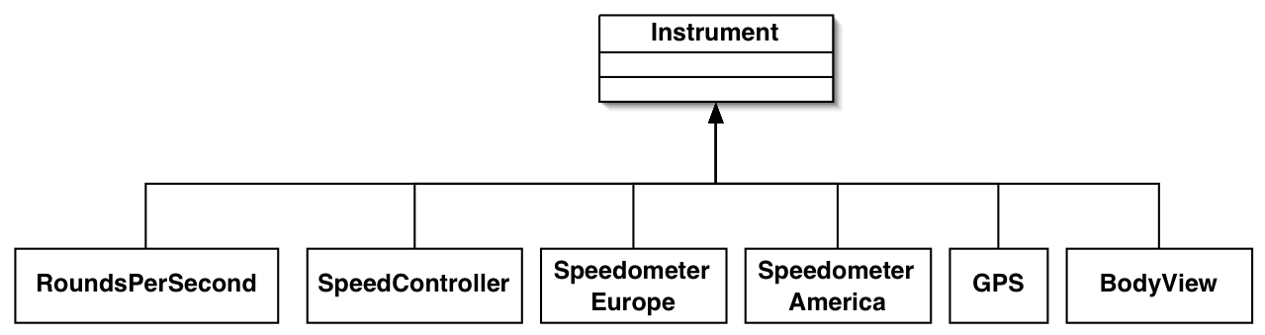
Figure 4: The instruments visualize the state and interact with the driven car (UML class diagram).

RoundsPerSecond:
Displays the rounds per second the player’s car.

SpeedController:
The SpeedController enables the player to increase and decrease the speed of its car.

SpeedometerEurope:
Displays the speed of the player’s car in kilometer per hour to the player.

SpeedometerAmerica:
Displays the speed the player’s car in miles per hour to the player.

GPS:
The GPS instrument displays the current position of the car driven by the player.

BodyView:
The BodyView displays the body image of the car driven by the player.

In the following we focus on the graphical components of Bumpers.

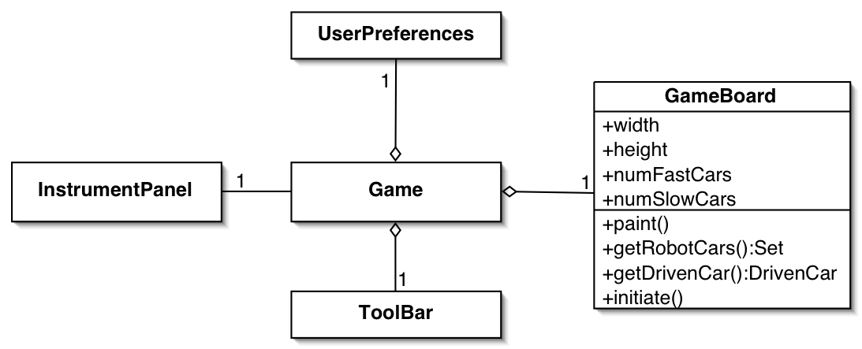
Figure 5: The graphical classes of Bumpers (UML class diagram).

BumpersWindow:
The BumpersWindow represents the main graphical window of Bumpers. All other graphical components are placed within the window.

ToolBar:
The ToolBar is a graphical component that offers the game control buttons for starting and stopping the game.

PreferenceDialog:
The preferences of Bumpers can be set by an instance of the PreferenceDialog class.

InstrumentPanel:
The InstrumentPanel of the player’s car is visualized in the BumpersWindow.

The following diagram gives an overview of all introduced classes and their relations.

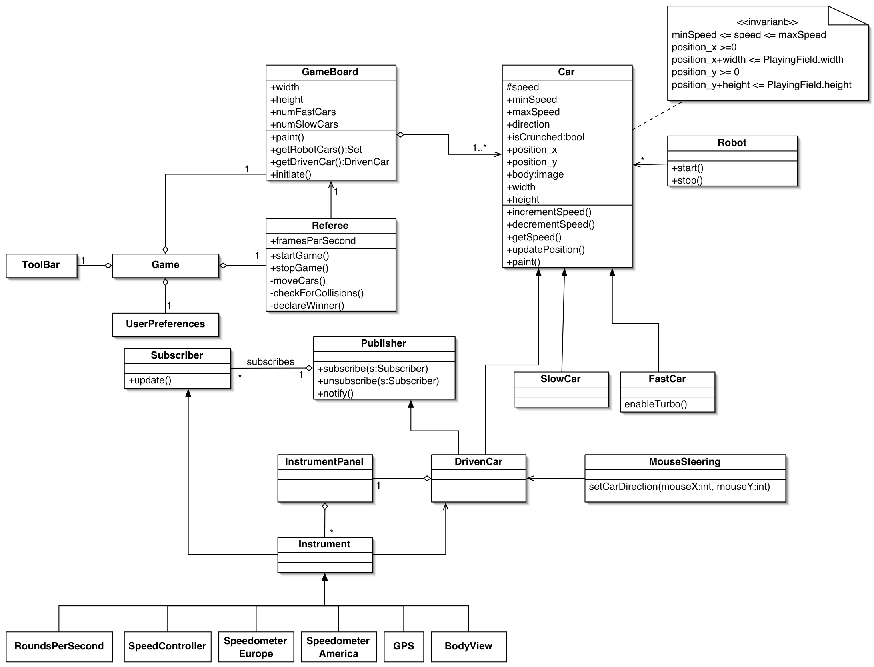
Figure 6: Overview of Bumpers object model (UML class diagram).

Dynamic model
The following figure gives an overview of the main game states.

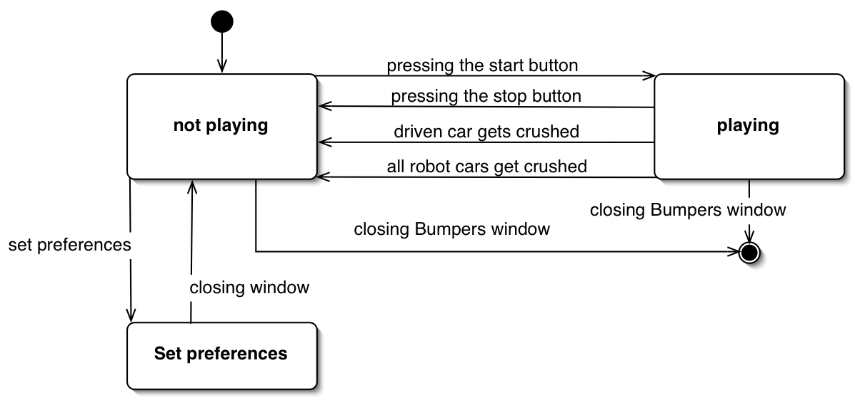
Figure 7: Overview of Bumpers main states (UML state diagram).
The startup state of Bumpers is ‘not playing’. The player can set the preferences of the game, start the game or exit the application. After setting the preferences, Bumpers returns to the ‘not playing’ state. The game starts by pressing the start control button of the tool bar and sets Bumpers to the state ‘playing’. This state is exited, if the player presses the stop button of the tool bar, the driven car of the player gets crunched or all robot cars get crunched. The whole Bumpers application can be terminated from either the “not playing” state or the “playing” state.

The next state diagram focuses on the car driving. Here we look at the “playing” state in more detail. The referee controls the state transitions.

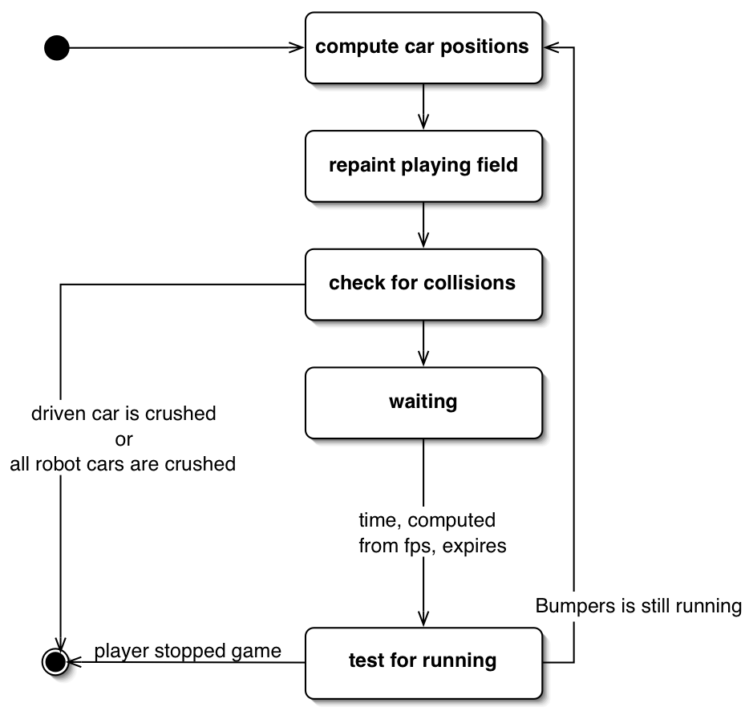
Figure 8: Overview of the playing loop of Bumpers (UML state diagram).

Bumpers runs through a loop of states. The loop starts with the computation of the new positions of all cars on the game board. The game board and all cars are repainted at their new positions. A test for collisions detects if a car gets crunched. If the driven car is crunched or all robot cars are crunched, the game stops and the player wined or lost the game. Based on the frames per second, the referee waits and tests, if the player has stopped the game by a control button. If so, the loop will be exited and the game stops. Otherwise, the loop starts again.

